**DE MONTFORT UNIVERSITY**

**BMPM5005 PROJECT MANAGEMENT DISSERTATION**

**ACADEMIC YEAR 2023-24**

**The Benefits of AI in Project Management: A Focus on the Information Technology Sector in India**

**Name: Praveena Sivakumar**

**P Number: P2807605**

**A dissertation submitted in part requirement for the award of Master’s in Project Management**

**Submission Date: 20/09/2024**

**Abstract**

The application of Artificial Intelligence (AI) in project management practices has recently drawn growing interest, especially in the flexible Indian Information Technology (IT) industry. The research questions for this dissertation are as follows: This dissertation seeks to examine the practical adoption and use of AI in project management generally and more specifically the identification of specific AI tools used, the perceived advantages and perceived disadvantages of such use, and the issues of concern in connection with its implementation. The research work is both quantitative and qualitative in nature, and data was collected using project managers and IT professionals’ questionnaires. Quantitative data analysis is used to establish correlation between variables in this case, the Chi-Square method is used to assess tool usage in relation to project efficiency and decision making.

The study outcomes show a relationship between the adoption of the AI tools and the numerous ways they are used for project management roles such as planning, risk management, and tasks automation. But the study also identifies some of the issues which include excessive costs of implementing this strategy and the requirement of employees with special training. Even while AI is regarded as improving decision-making attributes, its benefits to project efficiency are still ambiguous. The study implies that although the arising concepts in project management hold a lot of potential, managers and other stakeholders must take into consideration costs associated with the implementation of modern technologies such as AI, and the workforce that would be needed to support and implement the same.

This research fills the gap in extant literature by providing actioned advice on how to mitigate the challenges and enhance the impact of AI in project management of IT organisations in India. It also gives direction for future work to investigate the extended effects of AI on projects’ results in the long term.

**Keywords**: Artificial Intelligence, Project management, Information Technology, IT sector, AI tools, risk management, decision making

**Word count:** 11073 [excluding Abstract, Table of contents, Acknowledgement, References, appendix]

Contents

**Chapter 1: Introduction** 6

**1.1 Background** 6

**1.2 Problem Statement** 7

**1.3 Research Aim** 7

**1.4 Research Objectives** 8

**1.5 Research Questions** 8

**1.6 Significance of the Study** 8

**1.7 Research Rationale** 9

**1.8 Scope of the Study** 9

**1.9 Structure of the Dissertation** 9

**Chapter 2: Literature Review** 11

**2.1. AI Strategy and Policy Framework in India** 11

**2.1.1 National AI Strategy: The Foundations** 11

**2.1.2 Challenges to AI Implementation in Project Management** 12

**2.1.3 Ethical and Legal Considerations** 12

**2.1.4 Actions for Government and Private Sector Collaboration** 12

**2.2 AI in the Indian IT Sector** 13

**2.2.1 AI in IT Project Delivery and Remote Work Challenges** 13

**2.2.2 Client-Vendor Relationships and AI Integration** 13

**2.2.3 AI as a Strategic Tool for Competitive Advantage** 14

**2.2.4 AI’s Role in Enhancing Efficiency and Innovation in IT Projects** 14

**2.2.5 Challenges of AI Adoption in the Indian IT Sector** 14

**2.2.6 The Future of AI in the Indian IT Sector** 15

**2.3 Organizational Support and AI in Project Management** 15

**2.3.1 Role of Organizational Culture in AI Adoption** 15

**2.3.2 Perceived Organizational Support and Employee Attitudes Toward AI** 16

**2.3.3 Leadership and Organizational Support in AI-Driven Project Management** 16

**2.3.4 Organizational Support and AI-Driven Decision-Making** 17

**2.4 AI's Role in Project Efficiency and Success Factors** 17

**2.4.1 Enhanced Decision-Making and Risk Management** 17

**2.4.2 AI's Role in Enhancing Communication and Collaboration** 17

**2.4.3 AI’s Contribution to Quality Management** 18

**2.5 Challenges and Future Directions in AI-Driven Project Management** 18

**2.5.1 Technical Challenges** 18

**2.5.2 Organizational Resistance and Change Management** 19

**2.5.3 Skill Shortages** 19

**2.5.4 Integration with Existing Project Management Tools** 19

**2.5.5 Ethical Considerations in AI Implementation** 20

**2.6 AI and Emerging Technologies in the Indian IT Sector** 20

**2.6.1 AI and Machine Learning in the Indian IT Landscape** 20

**2.6.2 AI’s Role in Enhancing Client–Vendor Relationships** 20

**2.7 AI’s Role in Project Success in the IT Sector** 21

**2.7.1 AI and Project Efficiency** 21

**2.7.2 Risk Management in IT Projects** 21

**2.7.3 AI and the Future of IT Project Management** 21

**2.8 Research Gaps** 22

**2.9 Theoretical Backings** 22

**2.10 Conclusion** 23

**Chapter 3: Research Methodology** 23

**3.1 Introduction** 23

**3.2 Research Design** 23

**3.3 Target Population** 24

**3.4 Sampling Method** 24

**3.5 Data Collection** 24

**3.6 Research Method** 25

**Chapter 4. Data Analysis** 26

**4.1 Introduction:** 26

**4.2 Data Analysis:** 26

**4.3 Demographic Overview** 27

**4.4 Objective 1: AI Applications in Project Management** 28

**4.5 Objective 2: AI and Project Planning Perceptions** 33

**4.6 Objective 3: Perceptions of AI Project Effectiveness** 39

**5. Discussion and Interpretation:** 48

**5.1 Objective 1: AI Applications in Project Management** 48

**5.2 Objective 2: Perceived Benefits of AI in Project Management** 48

**5.3 Objective 3: Challenges vs. Benefits of AI Implementation** 49

**6. Conclusion and Recommendations** 51

**6.1 Conclusion** 51

**6.2 Implications of research findings:** 51

**6.3 Recommendations:** 52

**6.4 Limitations** 53

**References:** 54

**Appendix 1: Ethical form** 59

**Appendix 2: Tables** 66

**Appendix 3: Discussion form** 77

**Acknowledgement**

It is my immense pleasure to extend my sincere thanks to all those who have invested their time and energy for this dissertation. To begin with, it is my immense pleasure to express how much I am grateful to my supervisor Emmanuel O. Odumosu who helped me throughout the main steps of my work, encouraging me to implement my ideas and providing useful suggestions. He has offered invaluable guidance in the formation of this work and the time he has spent in guiding me on this process is appreciated.

I would also find it necessary to express my gratitude to all the participants who engaged in the data collection exercise. I would also like to appreciate the cooperation of all the participants in this study to whom this research would not have been possible. It is with aspiration to their knowledge and perceptions that this study has been deemed possible.

Last but not the least, I am grateful to my family and friends who have been supportive, politically correct and encouraging from the start to the end of this rigorous but fruitful journey.

# **Chapter 1: Introduction**

## **1.1 Background**

Artificial Intelligence is among the revolutionary technologies of this century in technology advancement, and it is potential is evident in different fields inclusive of information technology. In management of projects, it has been used, and it continues to be applied to increase planning, risk analysis, decision analysis, and the manner resources are utilized in projects (Niederman, 2021). Subsequently, the use of AI in the project management has been of great relevancy especially in the IT sector which require innovative solutions to meet the dynamism, sophistication, and faster rates of development. Computerized project management solution utilizing artificial intelligence has illustrated the ability to enhance efficiency, eliminate bias, and enable quick decision-making and, therefore, considered a prime area of study for organizations across the world.

Such success of the IT sector in the context of India can be regarded as one of the major achievements towards its development. India’s IT sector provides technological solutions to worldwide projects and creating project management AI would be an optimal way to evaluate such technology in this country (Chatterjee, 2021). By focusing on project management, AI is well-placed to support growth in India’s rapidly growing IT industry and the country’s strategic importance to outsourcing awakening the competitive edge of Indian organizations in project management.

## **1.2 Problem Statement**

Although it is acknowledged that AI can improve project management, there are issues unique to the India IT industry that prevent the use of the technology on a large scale. Some of them are technical constraints, organizational sets, skill deficits, and data issues (Venumuddala & Kamath, 2023). While most of the Indian IT organizations are looking forward to adopting AI technologies, there is not enough literature existed to explain the use and benefits of AI enablers for the IT project management in Indian context. Additionally, AI has challenges such as where project managers experience challenges in making AI assimilate traditional projects, largely because of the difficult understandings of AI and the skills that are required in its execution (Bhoola, 2023).

Therefore, this research aims at filling these gaps by studying the advantages of AI in project management in the Indian IT industry and emerging AI applications for it, and the issues faced by project managers while utilizing the AI solutions.

## **1.3 Research Aim**

The aim of this research is to explore the benefits of AI in project management, with a specific focus on the Indian IT sector. The study seeks to understand how AI tools can enhance various aspects of project management, such as planning, scheduling, risk management, decision-making, and overall project efficiency. By examining the current state of AI adoption in the Indian IT industry, this research aims to provide valuable insights into the practical applications of AI and the challenges faced by project managers in integrating AI into their workflows.

## **1.4 Research Objectives**

To achieve the aim of the study, the following objectives have been established:

1. To identify specific AI applications that can be used in project management within the Indian IT sector.
2. To evaluate the perceived benefits of AI tools in improving project management processes such as planning, risk management, and decision-making.
3. To provide recommendations for overcoming these challenges and maximizing the benefits of AI in project management within the Indian IT industry.

## **1.5 Research Questions**

To guide the research, the following questions will be addressed:

1. What AI tools and technologies are currently being used in project management in the Indian IT sector?
2. How do project managers perceive the benefits of AI in improving project outcomes such as efficiency, accuracy, and decision-making?
3. What are the key challenges and barriers to adopting AI in project management within the Indian IT industry?

## **1.6 Significance of the Study**

The study is significant for several reasons. First, it addresses a critical gap in the literature by focusing specifically on the use of AI in project management within the Indian IT sector. As AI technologies continue to evolve and become more accessible, understanding their potential impact on project management is essential for organizations looking to stay competitive. Second, the research provides practical insights into the challenges faced by project managers in adopting AI, offering recommendations that can help organizations navigate the complexities of AI integration. The highlighting the role of AI in driving innovation and improving project efficiency in one of the country’s most important industries.

## **1.7 Research Rationale**

There are no doubts that use of AI can enhance the decision-making processes and the efficiency of the project management processes. Levitt and Kunz (2009) discussing the benefits of application of AI in project management stated that, through use of complex algorithms and analytic ability, the system is capable of processing large volumes of data, and this can help the project manager to make the right decisions with respect to the timelines, costs, and resource organization. Project management can benefit from AI in terms of automation and efficiency to perform tasks that were repetitive and time-consuming while making recommendations that can greatly improve the statuses of numerous practices (Savio & Ali, 2022).

Still, there is immense potential for the implementation of AI in project management in India, and it is currently on the initial stages. Some familiar challenges faced by many organisations include implementation of AI to integrate it into the current frameworks, data management within the AI system as well as the ability to adapt existing AI tools to fit a certain project (Venumuddala & Kamath, 2023). Moreover, there is a vast skill gap when it comes to the actual practice of implementing and managing artificial intelligence technologies which are a huge problem for the widespread adoption of AI in the Indian IT market (Chatterjee, 2021).

## **1.8 Scope of the Study**

The geographical focus on India is important because India occupies a leading position in the world IT market and actively promotes the use of artificial intelligence (Srivastava, 2022). AI has been active promoted in India as a tool of the government’s digital initiatives to ensure that the country retains its competitiveness in the global market (Chatterjee, 2021). Therefore, the study seeks to establish how AI is influencing the project management in India’s IT industry.

## **1.9 Structure of the Dissertation**

This dissertation is structured into the following chapters:

**Chapter 1: Introduction**: This chapter sets the stage for the research by providing an overview of the study’s background, objectives, and significance. It outlines the problem statement, research questions, and the scope of the investigation.

**Chapter 2: Literature Review**: In this chapter, a comprehensive review of existing literature is presented, focusing on current research related to AI applications in project management. It covers theoretical perspectives, previous findings, and gaps in the literature.

**Chapter 3: Research Methodology:** This chapter details the research design and methods used to collect and analyze data. It includes an explanation of the research approach, sampling techniques, and data collection methods. Additionally, the chapter describes the tools and techniques employed for data analysis, specifically the use of IBM SPSS and the Chi-Square method to derive meaningful insights from the data.

**Chapter 4: Data Analysis and Results:** This chapter presents the findings from the data analysis. It includes detailed statistical results, including the application of Chi-Square tests to evaluate relationships between variables. The chapter provides a thorough breakdown of the data, highlighting key patterns and significant findings relevant to the research objectives.

**Chapter 5: Discussion:** Here, the results are interpreted and discussed in relation to the research questions and objectives. This chapter examines the implications of the findings, exploring how they contribute to the understanding of AI’s role in project management. It compares the results with existing literature, discusses potential reasons for observed patterns, and reflects on the significance of the findings in the broader context of AI integration in project management.

**Chapter 6: Conclusion and Recommendations:** The concluding chapter summarizes the main findings of the study, drawing conclusions based on the data analysis and discussion. It outlines practical recommendations for organizations in the Indian IT sector regarding AI adoption and its application in project management.

# **Chapter 2: Literature Review**

## **2.1. AI Strategy and Policy Framework in India**

### **2.1.1 National AI Strategy: The Foundations**

The “National Strategy for Artificial Intelligence” released by NITI Aayog in 2018 explains India’s intentions for dominance in AI and utilizing this technology for bringing socio-economic change for governance. Chatterjee (2021) states that the Indian Government has taken a progressive approach to portraying AI as the centre of digital and innovation policies to make it a national agenda. The outlined strategy for AI development in India looks at the country as the synthesis of solutions for its local problems in several sectors that include agriculture, healthcare, education, smart cities, and smart mobility. It therefore stresses a need to have a complete Artificial Intelligence ecosystem that accommodates for well framed policy interventions, integral support infrastructure, development of a competent talent pool, and engaging public-private partnerships. This policy is important for the growth of AI usage in different industries and specifically information technology that is important for digital economy of the country.

### **2.1.2 Challenges to AI Implementation in Project Management**

However, there are several challenges that one must face to implement AI in the project management even if the Indian government works proactively in this direction. Chatterjee (2021) has placed primary barrier in the form of the scarcity of qualified, talented people who can manage AI and incorporate them into the ongoing project management procedures. While IT industry in India has quite evolved there is short supply of skilled talent in areas like data science, machine learning, and AI ethics. Also, the use of AI translates to significant hardware, in terms of hardware, processing, and storage facilities, bandwidth, and connection to the internet which remain blighted in most part of the world that is outside urban cities. Moreover, reactions of project managers and employees who may consider the change a threat to being displaced or being presented with new processes that differ from traditional project management.

### **2.1.3 Ethical and Legal Considerations**

The decision to implement AI has significant moral and legal consequences, as is accentuated in relation to the Indian governmental policy. Mentioned by Venumuddala and Kamath (2023), the Indian government has highlighted the need for appropriate ethical frameworks for the AI technologies, as for the algorithmic bias, data privacy, and accountability of the decisions. When applying or incorporating algorithms that make decisions or suggest, they should not be prejudiced in project management techniques. For instance, AI systems that are used in resource allocation, risk prediction, or team performance evaluation will only reproduce bias if the data on which they rely is itself bias.

### **2.1.4 Actions for Government and Private Sector Collaboration**

To overcome the mentioned challenges related to the application of artificial intelligence in managing projects, joint efforts of the authorities and the private sector are more focuses. The establishment of public-private partnerships in implementing various AI projects and initiatives is the government’s attempt to build an environment that supports innovation as well as address several practical challenges to AI implementation. The major IT giants from India such as Tata Consultancy Services (TCS), Infosys and Wipro are exploring new techniques in combining emerging technologies such as artificial intelligence in project management. Some are not only progressing AI technologies but also collaborating with the government to align the use of AI with the country’s direction and norms. Furthermore, the Central government of India launched its ‘AI for All’ initiative aimed at the making of AI knowledge and skills’ training available at large, which appears as an outright necessity when it comes to incorporating IT projects and AI technologies equally (Venumuddala & Kamath, 2023).

## **2.2 AI in the Indian IT Sector**

### **2.2.1 AI in IT Project Delivery and Remote Work Challenges**

Venumuddala and Kamath (2023) study how the management and delivery of AI solutions and work systems in the IT industry in India has been impacted. They stress the issue arising from increased opportunities of remote work many companies face today, especially due to the COVID-19 virus. AI has now been indispensable to controlling distributed teams and the continuity of the projects by promoting communication, streamlining work, and offering real-time project monitoring.

### **2.2.2 Client-Vendor Relationships and AI Integration**

In the IT industry of India, client vendor relationship is considered as one of the most crucial factors especially considering the global connectivity of the industry. In Venumuddala and Kamath (2023), authors further discuss how these dynamics are evolving through AI and where – on the contract side, for example, or in issue resolution and performance monitoring. Self-service tools enable clients to have more influence in aspects such as timelines and deliverables while helping vendors deliver what is expected by their clients. Such dashboards give real-time feed on the project’s status, and progress acquisition helps both parties make informed decisions. In the same regard, AI minimizes risks through early detection, which is important for organizations working on large-scale and complex projects that are widespread in the Indian IT segment.

### **2.2.3 AI as a Strategic Tool for Competitive Advantage**

The Indian IT industry is very intensive, and firms search for the ways to assert their positions on the global level. It is pipe, that artificial intelligence (AI) has become a vital tool for achieving competitive advantage especially through the application of Project Management and improving service delivery. This is according to Babu and Vasumathi’s (2023) observation, which reveals that organizations that tap into AI-based technologies as well as incorporate them as innovative tools in project management boost their performance in terms of efficiency, cost-effectiveness, and customer satisfaction as compared to rivals in their respective industries. AI had been used in restricted factors such as automation as well as data analysis in the IT industry of India; However, it has advanced to a higher level of functions including resource allocation, recruitment, and client management. For instance, AI applied in project management allows project managers to reduce resources’ misallocation as the tools can identify the skills required on the project and match them with the most appropriate human capital, allowing the right resources for a specific project to be applied effectively which reduces time wastage due to talent mismatch. According to Babu and Vasumathi (2023), organisational support should be followed as a key measure in the success of AI implementation.

### **2.2.4 AI’s Role in Enhancing Efficiency and Innovation in IT Projects**

The use of AI to improve project efficiency is another common idea reported in the literature. In their article, Levitt & Kunz (2009) argue that AI has the capacity of enhancing project scheduling, resource usage and additionally enhances sharing of information. These advantages are even more critical for the Indian IT industry because the scale, and scope of projects are not minor. There are AI tools applicable for effective management of large volumes of data pertaining to every project and they provide instant information and decision-making abilities.

### **2.2.5 Challenges of AI Adoption in the Indian IT Sector**

It is essential to consider the opportunities of AI implementation in the Indian IT industry, however there are certain obstacles to face. According to Hashfi and Raharjo (2021), some of the challenges affecting AI implementation include the cost of the technologies, the reluctance of project managers and data privacy and security. However, these challenges are compounded in India due to the nature and size of IT projects. One of the major problems is the lack of qualified personnel with experience in AI and Machine learning while the country provides Human Resources abundance in IT talents. This deficiency of skills requires the need to institute special training and put more investment into education.

### **2.2.6 The Future of AI in the Indian IT Sector**

In the future, the prospects for AI development in the Indian IT sector are quite optimistic. According to Ong and Uddin (2023), the application of AI in managing projects in the future will still advance even further in areas of better project forecasting, automation and in decision-making. As pointed out by Chatterjee (2021) Indian government support for AI advancement will determine the fate of AI in the future. The government’s support for AI research and development as well as the implementation of policies encouraging the use of ethical artificial intelligence helps in the promotion of this technology. While India continues to fight to cement its status of one of the world’s dominant IT industries, AI is going to become a competitive advantage for companies that successfully adapt it. As such, the partnership between the government, the industry, and academic institutions will be vital in the promotion of innovation and the management of issues related to the implementation of advanced technologies such as AI. Therefore, unless concerns such as shortage of skilled workers or data security are managed appropriately, there is every potential for AI to revolutionize project management within the IT industry in India through the use of automation as well as the improvement of decision-making processes and project performance. Therefore, with the right support AI could bring transformations to project management, competitiveness, and innovation in the market.

## **2.3 Organizational Support and AI in Project Management**

### **2.3.1 Role of Organizational Culture in AI Adoption**

Organizational culture is a second factor that helps in creating a proper environment for the use of artificial intelligence. Babu and Vasumathi (2023) make specific observations by noting that firms that encourage creativity within their working environment regarding technology foster increased adoption of AI within project management settings. Contrarily, organizational culture that does not support change can negatively impact AI implementation, since adopting recent technologies may be met with employees using new tools or even lack required skills to interact with AI systems.

### **2.3.2 Perceived Organizational Support and Employee Attitudes Toward AI**

This paper also finds that the level of POS has a significant impact towards employees’ attitudes for AI on Project Management. Babu and Vasumathi (2023) notes that the favourable attitude towards AI tools is favoured by the recognition of the organizational resources, communication on AI’s position, and professional training. It reduces fears and resistances to recent technology usage, and as a result, increases an interest in artificial intelligence applications. According to their studies, they opine that when employees are engaged and/or supported by their employers, they will easily perceive AI as having positive impact instead of a threat. Besides, perceived organizational support may reduce risks stemming from job automation by perceiving AI as the supplement to humans. Explaining to different stakeholders the ways AI is going to be helpful in enhancing processes involved in project management also helps in making them less afraid and more optimistic about AI. Through the testing of AI instruments and the inclusion of talk about AI tools as an instrument, it is possible to organize the favourable conditions for successful AI implementation in PM.

### **2.3.3 Leadership and Organizational Support in AI-Driven Project Management**

Leadership plays a significant role in providing direction on the application of AI in PM and ensuring that organizations support AI implementation within their framework. Regarding this, Brynjolfsson and McElheran (2016) stress that leadership must synchronise the objectives of the organisation with the opportunities offered by AI to make its implementation as efficient as possible. There is a cultural change that needs to occur where leaders need to set the tone that puts AI forward as a priority of importance and respond to concerns that project teams and managers have about using AI tools in their work. Avolio and Bass (2004) also explained that leaders have to provide resources that are required for AI implementation such as investment in structures, obtaining quality data, and training. This commitment is important when most project teams are to be provided with tools and support for the implementation of artificial intelligence.

### **2.3.4 Organizational Support and AI-Driven Decision-Making**

AI can significantly enhance decision-making for project management by presenting timely information and quick analyses based on the available data. In line with Babu and Vasumathi (2023), these authors also argue that there is a significant interaction between the level of organisational support and the performance of AI in this domain. Some authors posit that organizations that engage in the requisite investment in infrastructure, data assets, and training empower project managers to apply AI tools more purposefully hence, making their decisions more informed. AI’s potential to assimilate terabytes of information, make sense of them, recognize threats, and offer mitigations can transform project management.

## **2.4 AI's Role in Project Efficiency and Success Factors**

### **2.4.1 Enhanced Decision-Making and Risk Management**

In their 2023 study (Babu and Vasumathi) focused on how the integration of AI as a tool along with perceived organizational support will improve the project performance by modifying the decisions made by the project managers. They observe that organizations investing in AI technologies and offering appropriate training and resources enhance the project outcomes significantly in the Indian IT sector such as risk management, efficient resources, and time management, etc.

### **2.4.2 AI's Role in Enhancing Communication and Collaboration**

Effective communication is one area where many projects succeed or fail, especially with regards to distributed teams, which is typical for IT companies. As pointed by (K. Williams and J. Brown in their 2023), these aspects can be enriched using AI tools, which provide real time updates, management of tasks and automated reports. These tools help foster coordination among team members in relation to the goals of the project and give each person an understanding of what his or her responsibilities are, so that there can be little to no confusion and consequent prolongation of the project. In the research by (R. Smith and A. Patel in 2024), established features of the AIM project management systems include real-time information and document conveyance alongside feedback. They also create and dispatch emails with automatically generated project progress updates, thus helping the project managers to keep an eye on the health of their projects and to resolve problems should there be any. When communication and collaboration are improved, AI tools, therefore, increase the chances of achieving the implementation goals of a project.

### **2.4.3 AI’s Contribution to Quality Management**

There is no doubt that AI holds exciting potential in improving the principles of quality management to the optimal level, particularly in IT related projects such as software development and system integration. It can assist in quality assurance to coordinate tests, check the code for mistakes, and predict potential problems. For instance, software testing and intelligent automation tools can perform testing to capture bugs or susceptibilities before the release and deployment stages and by leveraging machine learning, identify challenging code parts based on previous experience. Implementing AI dealings with quality conundrums helps to prevent the execution massive and costly rework, which makes it crucial to maintain project quality (Kaur, 2020; Sharma & Sharma, 2021).

## **2.5 Challenges and Future Directions in AI-Driven Project Management**

### **2.5.1 Technical Challenges**

One of the most apparent obstacles in applying AI in project management is the technical issue required to integrate AI into a project. According to Hashfi and Raharjo (2021), there are significant challenges, including the excessive cost of acquiring and implementing AI technologies that makes the process a challenge particularly for SMEs. Such systems use machine learning algorithms and other predictive analytics tools that require sophisticated hardware, software, and technical knowledge that organizations with limited resources may find challenging to implement AI in their project planning. The other concern is the dependability of the AI systems because, even though AI is handy, it is not perfect. Currently, AI systems work based on the data the algorithm has been provided with, and, therefore, if these data have intrinsic weaknesses, then the output will also be equally distorted. According to Niederman (2021), several organizations are still wary of the accuracy of AI predictions, especially in the management of complex and fluid projects, thus issues of reducing human intervention in organizational processes through reliance on AI.

### **2.5.2 Organizational Resistance and Change Management**

Indeed, one of the most crucial barriers of using AI is the resistance to change within organizations. Many project managers and team members are afraid of the AI implementation because of potential talent loss, low awareness of the AI technologies, or due to the changes in the project management approaches. Ong and Uddin (2023) have stressed that while implementing and adopting AI has numerous advantages, resistance from people allows the technology to act as a barrier to AI implementation into project management. Additionally, the culture of an organization determines the extent of implementation of AI in an organization. According to Babu and Vasumathi (2023) specification and coordination of AI project management also entail creating culture that support innovation and learning. They focus on the need for corporations to allocate resources towards the development of their employees and stating that in projects using AI it does not diminish the role of human input and intelligence in decision making.

### **2.5.3 Skill Shortages**

Another challenge that organisations face with the implementation of AI is lack of experienced personnel qualified to operate manage and analyse the AI. Chatterjee (2021) established that, the available talent of data scientists, artificial intelligence engineers, and IT professionals with AI skills is limited and scarce with most talent being found in developed countries or in developed regions within the developing countries. In India especially in the IT sector this shortage offends the implementation of the AI in the project management field.

### **2.5.4 Integration with Existing Project Management Tools**

The implementation of AI is another issue because its integration with other project management tools and systems is a problem. Project management software has been purchased and implemented by many organizations, and integrating AI-based tools requires being done seamlessly in the middle of projects. Bhoola (2023) asserts that integration with existing frameworks becomes crucial, and it may call for either bespoke coding or acquisition of relevant software. Furthermore, integration issues are not only technical but also involve the structure and AI-generated data and reports to Agile, Scrum, or Waterfall project management methodologies. More specifically, Niederman (2021) has acknowledged that AI assists Agile PM in optimizing overall utilization of resources by giving data about the performances from the teams and the risks for a project, though this is only possible if the applications of AI are incorporated into the Agile procedures adequately.

### **2.5.5 Ethical Considerations in AI Implementation**

Since AI integrated with solution formulation, it is essential for project manager to know about the inequitable nature of AI algorithms and the resultant decisions. For example, the AI systems, which learn from the biased data, will reproduce inequality in distribution of resources and risks mitigations, evaluation of teams and their performance. Levitt and Kunz (2009) also stress accountability stating that there are rules on who is responsible for the error/ failure in AI. Also, it is necessary to be transparent about the process of decision-making in an artificial intelligence system and to make people in charge of such processes report to humans.

## **2.6 AI and Emerging Technologies in the Indian IT Sector**

### **2.6.1 AI and Machine Learning in the Indian IT Landscape**

Ullal et al., (2020) provide insights on how the use of AI and ML is disrupting the Indian services sector particularly information technology (IT). They can assist project managers in dealing with a bulk of data to make wiser decisions, identify potential risks and utilize resources more effectively. In the rapidly expanding IT industry in India, AI and ML are applied to automate processes and optimize project results. For instance, machine learning can estimate project delays from previous data, so the managers take precautions in advance. It also enhances the accuracy in project planning, particularly in scheduling and cost control as the project schedules are becoming congested and demands from clients on projects are rapidly escalating. This trend is most observable in large IT companies that undertake multiple projects and require efficient and equally important, flexible solutions.

### **2.6.2 AI’s Role in Enhancing Client–Vendor Relationships**

Client and vendor relations are critical to managing projects in the Indian Information Technology industry. Venumuddala and Kamath (2023) elaborate on how AI can improve these aspects of relationships through the improvement of communication, transparency, and performance evaluation. The use of artificial intelligence can significantly optimize repetitive tasks such as creating performance reports, monitoring contract obligations, or informing clients about the projects’ progress in real-time, thereby raising transparency and reliability and reducing the likelihood of conflict. Furthermore, based on history and feedback of previous and current projects and clients, one can identify areas of service delivery enhancement that could only be done using AI.

## **2.7 AI’s Role in Project Success in the IT Sector**

### **2.7.1 AI and Project Efficiency**

Srivastava (2022) notes that AI improves project efficiency, which is one of the most crucial benefits to the overall success of a project. AI solutions provide regular and routine processes like scheduling, planning resources, and tracking the progress of works which are often boring and prone to errors. This automation helps the project manager to focus on areas such as stakeholder management and control of risk on the project. Further, the incorporation of AI-driven automation makes the process more precise; hence, minimizes delays and costs.

### **2.7.2 Risk Management in IT Projects**

Managing risks stands as one of the most complicated areas of project management in the IT industry due to uncertainty and technicality of projects in the field. As pointed out by Venumuddala and Kamath (2023), AI’s ability to learn from past data, recognize patterns, and forecast risks is the core of the improved risk management paradigm. Machine learning algorithms can predict the probability of risks, such as technical problem, cost control, or schedule issues, based on data from previous projects. Such predictions help project managers prepare for the occurrence of risks within the project before they worsen.

### **2.7.3 AI and the Future of IT Project Management**

Pursuing the discussion of the application of AI in IT project management, it is expected to evolve in the future because the more organizations become aware of the role of AI in improving project results. Ong and Uddin (2023) also state that AI will be increasingly integrated into project management approaches and will not only affect the delivery of specific projects, but also the management of project portfolios. AI will also help to match project strategies to business goals more effectively and allocate resources to the right projects.

## **2.8 Research Gaps**

The literature review highlights several research gaps that this dissertation aims to address:

1. Implementation Challenges: While existing studies discuss the general challenges of AI implementation, there is limited research focusing specifically on the nuances of these challenges within the Indian IT sector. This includes the shortage of skilled talent and the ethical considerations of AI adoption in project management.
2. Organizational Support: Although organizational support is recognized as crucial for AI adoption, there is a lack of empirical research on how specific aspects of organizational culture and support mechanisms impact the successful integration of AI tools in project management.
3. Impact on Job Roles: The literature touches on the potential for job displacement due to AI but lacks a detailed exploration of how AI-driven automation affects different project management roles and the effectiveness of reskilling initiatives.
4. Sector-Specific Insights: There is a need for more targeted research on how AI is impacting project management within the Indian IT sector, particularly in terms of competitive advantage, efficiency, and innovation.

## **2.9 Theoretical Backings**

The theoretical framework for this dissertation draws on several key theories and models:

**Technology Acceptance Model (TAM):** This model explains how users come to accept and use recent technologies. It will be used to assess how project managers in the Indian IT sector perceive and adopt AI tools.

**Diffusion of Innovations Theory:** This theory helps to understand how innovations spread within organizations and sectors. It will be applied to analyze the adoption and integration of AI in project management practices.

**Resource-Based View (RBV):** This perspective will be used to evaluate how AI as a strategic resource can provide competitive advantages to organizations in the Indian IT sector.

**Change Management Theory:** This theory will inform the analysis of how organizations manage the transition to AI-driven project management, including the role of leadership and organizational support.

## **2.10 Conclusion**

In conclusion, this literature review has provided a comprehensive overview of the current state of AI in project management, with a particular focus on the Indian IT sector. It has highlighted the foundational policies and strategies guiding AI development, the disruptive impact of AI on project management practices, and the critical role of organizational support in facilitating AI adoption. The review has also identified significant research gaps, including the need for deeper insights into implementation challenges, organizational support mechanisms, and the impact of AI on job roles. By addressing these gaps, this dissertation aims to contribute valuable knowledge to the field of AI-driven project management and offer practical recommendations for enhancing the integration of AI tools in the Indian IT sector.

## **Chapter 3: Research Methodology**

## **3.1 Introduction**

This chapter gives the research design for conducting the research on the impacts of AI in project management focusing on IT industry. The purpose of the study is to find out how AI contributes to the improvement of the PM processes and the perceived advantages, as well as to recognize some difficulties related to the AI integration. Sections addressed in this case include the research methodology, target population, the nature of sample used demographic data, approach used in data gathering for this study and the method used in data analysis.

## **3.2 Research Design**

In the present study, the research approach that is employed is quantitative research which relies on a survey technique. This method is applicable when organizing enormous number of respondents and quantifying the attitude, opinion, and experience towards the application of AI in project management. By emphasizing data collection procedure, the research sets an intention to contribute to the understanding of the ways and outcomes of using AI in project management.

## **3.3 Target Population**

The study entails project managers, IT professionals, and any other stakeholders interested in project management within the IT industry in India. The selection of professionals in the IT sector guarantees that the respondents are knowledgeable and experienced with the research objectives, offering valuable insights. The population for this study is between 25 to 30 participants.

## **3.4 Sampling Method**

A purposive technique is applied in which the participants are selected consciously following several criteria touching on the use of AI in project management. This is a non-probability sampling technique which is of relevance to the study because it is an effective way of identifying persons who could offer maximum relevant information on the research questions. The sample size of 25 to 30 participants was chosen based on the need for in-depth insights and the feasibility of gathering detailed and reliable data. This size allows for a manageable yet informative set of responses, providing dependable and statistically grounded results.

## **3.5 Data Collection**

The survey data will be collected using an online survey questionnaire which will be circulated through e-mail and social media to the participants from the IT organizations. The questionnaire will consist of closed-ended questions designed to gather quantitative data, focusing on: The questionnaire will consist of closed-ended questions designed to gather quantitative data, focusing on:

**Demographics:** Demographic data about the respondents including: their job role, years of experience, and their exposure to AI tools.

**AI Applications in Project Management:** List down the AI tools and technologies that are being used in project management in the IT field now.

**Perceived Benefits:** Evaluation on how aspects such as project planning, scheduling management of risks and decision making are conceived to be improved by AI.

**Challenges in AI Integration:** The best approach on how the various barriers and challenges to the adoption of AI technologies can be better understood by project managers.

**Future Prospects:** In-depth ideas of the prospects of the AI in project management and a readiness to implement AI-centered solutions.

## **3.6 Research Method**

For data analysis, IBM SPSS software is used to examine the responses collected from the survey. The primary statistical technique employed is the Chi-Square method, which is used to assess relationships between variables such as AI tool usage, perceived benefits, and challenges. Chi-Square test is ideal for assessment of nominal data and the conclusion as to whether there is desirable association between various variables in the study including the frequency with which AI tool is used and the variety of application used in project management. Moreover, the Somers’ d and Kendall’s tau, the symmetric and directional measures, are applied to introduce more findings on the strength and direction of the relations.

**3.7 Ethical Considerations**

**Informed Consent:** Features of the study, rights of the participants, their duties and further consent will be explained to participants. Permission will be sought before they start conducting the survey.

**Confidentiality:** All these responses will be collected and will not identify any participant; thus, the anonymity of participants’ responses will be well protected. All the data collected in this research will be kept secure and can only be used for the purpose of this research.

**Data Protection:** This study will ensure the protection of participants’ data through adherence to data protection laws to avoid.

# **Chapter 4. Data Analysis**

## **4.1 Introduction:**

The purpose of this research was to understand the adoption and effectiveness of AI tools in project management with reference to the Indian IT industry. To do this, a more formal process was followed, which included the completion of survey questionnaires by project managers, IT professionals and other industry representatives.

The study adopted a quantitative research strategy, which based on survey questionnaire data. To explore the topics of usage and perception of AI in project management this survey was carefully designed into several sections. The primary areas were as follows, demographic data, uses of AI in project management, perceived advantages, barriers, and development expectations. The survey questions focused on the following core questions: The kinds of AI tools being utilized, the frequency at which they are used and the extent to which AI is seen to be having an impact across various aspects of project management.

## **4.2 Data Analysis:**

The data analysis was done with the aid of IBM SPSS software that enabled different statistical approaches to testing relations between variables. The Chi-Square test was the primary analytical technique employed to examine relationships between categorical variables. This test helps in determining whether there are statistically significant associations between variables, such as the presence of AI tools and their specific applications or perceived benefits. As to the rationale for the usage of Chi-Square the notion is in evidenced ability of this analysis to establish the presence of a statistically significant relationship between two or more categorical variables. This method however is more useful when a small number of participants were sampled whereby it is useful in determining if trends observed in the data are genuine or by chance alone.

Also, the study examines the popularity of using AI tools in relation to the attitude toward applying this concept to project management. As with frequencies and patterns, this approach reveals useful information with no assumption of normal distribution which is feasible for this study’s sample size.

Directional and symmetric measures, such as Somers' d and Kendall’s tau-b, were also applied to complement the Chi-Square tests. These methods provide additional insight into the strength and direction of associations between variables, enabling a more nuanced interpretation of the data.

The analysis involved several key steps:

**Data Preparation**: Cleaning and organizing the collected data to ensure accuracy and completeness.

**Descriptive Statistics**: Summarizing the basic features of the data, including frequencies and percentages for categorical variables.

**Chi-Square Analysis**: Assessing the relationships between categorical variables to identify significant associations.

**Directional and Symmetric Measures**: Evaluating the strength and direction of relationships between variables to provide a comprehensive understanding of the data.

## **4.3 Demographic Overview**

Before diving into the main analysis, it is essential to understand the demographic characteristics of the survey participants. The demographic data includes:

Job Positions: A mix of project managers, IT professionals, and stakeholders.

Experience Levels: Ranging from entry-level to senior management.

Organization Size: Varied, including small, medium, and large enterprises.

AI Tool Usage: Frequency and types of AI tools used across different organizations.

## **4.4 Objective 1: AI Applications in Project Management**

To address Objective 1, which aims to identify specific AI applications used in project management within the Indian IT sector, a Chi-Square analysis was performed on data from questions about AI tool usage, types of AI applications, and the frequency of their use. The results reveal a significant relationship between whether organizations use AI tools and the specific AI applications they employ. The Chi-Square tests show a Pearson Chi-Square value of 21.225 (p = 0.031) and a Likelihood Ratio value of 26.962 (p = 0.005), indicating that organizations using AI tools tend to employ a broader range of AI applications, such as those for data analysis, risk management, task automation, and scheduling.

Further, the analysis of AI tool usage frequency indicates a significant association with the frequency of application in daily project management. The Pearson Chi-Square value of 9.525 (p = 0.049) and the Likelihood Ratio value of 10.465 (p = 0.033) suggest that organizations using AI tools more frequently incorporate them consistently across various project management tasks.

Directional and symmetric measures support these findings, with Somers' d values reflecting a moderate negative association (e.g., -0.389, p = 0.019) between AI tool usage and the variety of applications employed. Kendall’s tau-b and tau-c values also indicate a significant negative association (e.g., -0.411, p = 0.019), reinforcing that organizations with AI tools utilize a wider range of applications. Although the positive Somers' d value (0.299, p = 0.056) for the frequency of use suggests a trend towards more integrated application, it is only marginally significant.

**Conceptual Framework Objective 1:**

The conceptual framework examines how the use of AI tools (independent variable) influences the frequency and range of AI applications in project management (dependent variable). Moderating factors include the types of AI applications, such as data analysis, risk management, task automation, and scheduling. These factors help assess how different AI applications affect the overall use of AI tools in project management.

AI Tools application in project management

Task automation

Data Analysis

Risk management

Process or Mechanism

Generation applications in project management

Fig.4.1 AI Applications in Project Management

According to the fig.4.1 AI Applications in Project Management indicates diverse ways in which AI is employed in project management with the percentage of each application. Cost Reduction remains and occupies the highest ratio of 20 percent. Nine percent and such capability include determination of wastage and probability of cost reduction through automation. Next, there is Planning & Scheduling which got 14% recognition from the respondents as to how AI helps in improving project timelines and resources. All three areas, namely Risk Management, Decision Making, and Project Efficiency were determined to be 17%. Four percent of the participants, explaining how the AI assists in identifying the risks, guiding decision-making processes, and improving project flows. Finally, the field that has the lowest recognition by respondents is Communication, which is mentioned by only 13% of the respondents, and this shows how artificial intelligence enhances teamwork especially through use of chatbots and natural language processing. Overall, the chart also draws focus to the fact that AI has a strong impact on various aspects of project management while improving both timely and quality dimensions of a project as well as decision-making advantages.

## **4.5 Objective 2: AI and Project Planning Perceptions**

Regarding Objective 2 which focuses on the perceived benefits of AI tools in project management, Chi-Square tests were used to analyze the associations between the job positions and perceptions of AI influences on some of the major functions of project management. The obtained findings indicate the lack of relationships between the participants’ jobs and their opinions on the implementation of AI in project upgrades on planning and scheduling (χ² = 12. 408, p = 0. 901), risks (χ² = 15. 942, p = 0. 720), and decision making (χ² = 17. 731, p = 0. 605). Likewise, the overall impact analysis of AI in the aspect of improving the overall project efficiency (χ² = 9. 569, p = 0. 846), enhanced communication (χ² = 14. 125, p = 0. 516), and cost saving (χ² = 28. 742, p = 0. 093) also revealed no significant correlation. Directional Measures including Somers’ d, and Kendall’s tau-b also support these findings and reveal that there is no correlation between specific job roles and the perception of the efficiency of AI in these fields. Subsequently, analysis sought to determine how the level of awareness that respondents have concerning AI influences their perception of the benefits that come with AI.

Regarding the result for AI’s improvement in project planning and scheduling, the Chi-Square value was 20. 490 with p = 0. 199, which does not reveal a correlation between awareness of AI and its influence on planning. Likewise, the test results for risk management (χ² = 11. 472, p = 0. 779), decision-making (χ² = 13. 042, p = 0. 670), and project efficiency (χ² = 16. 852, p = 0. 155) also revealed insignificant variations between the groups regarding how effective they perceive AI to be in relation to their level of the same applied for the cases of communication (χ² = 8. 682, p = 0. 730) and cost reduction (χ² = 16. 819, p = 0. 397) where the level of familiarity with AI did not affect responses given.

**Conceptual framework of objective 2:**

It represents the relationships between AI tools in project management and various project management functions. The benefits of AI in project management, specifically regarding planning, scheduling, risk management, decision-making, project efficiency, communication, and cost-saving. The results show no significant variation in these perceptions across job positions. This indicates that the perceived benefits of AI are consistent regardless of one's role within the organization.

Fig.4.2 AI and Project Planning Perceptions

According to the Fig.4.2 with the title AI and Project Planning Perceptions displays the view of the respondents concerning the application of AI in project planning. The survey responses are divided into five categories: Yes, No, Not Sure, Very Yes and Very No. The largest portion which is 50% means that the participants half approve the statement on the role of AI in project planning phase. 23. There were 3% of respondents who responded neutrally that they have not agreed or disagreed on any of the statements. A smaller percentage, 13. 3 % was the percentage of respondents who responded ‘‘disagree’ to the statement. Within the distribution of responses, the three most extreme – the Strongly Agreed, the Strongly Disagreed – were of the same measure at six. 7% each. Altogether, it could be stated that the chart indicates a prominent level of consensus with the notion identifying the importance of AI in project planning processes; however, the separated neutral and dissent view indicate a certain need to address the usefulness of AI more distinctly in terms of project management.

# **4.6 Objective 3: Perceptions of AI Project Effectiveness**

**High Implementation Costs vs. AI Improved Planning & Scheduling**

A chi-square test was also conducted to determine the relationship between the independent high implementation costs and dependent variable of perceived benefits, relating to AI enhancing project planning and scheduling. The findings reveal the fact that the Pearson Chi-Square statistic is equal 66. 792. For the corresponding p-value it follows 0. 381. Since the p-value is greater than the commonly accepted significance level of 0.05, we fail to reject the null hypothesis. This means that the implementation cost of AI does not have any correlation with the perception that AI has enhanced project planning and scheduling costs in project organizations.

Further, Somers’ d value = 0. 198 although positive, gives an indication of a little strength of the relationship between the two variables. However, to secure a better understanding of the potential relation between RF and stroke risk, this measure has an approximate significance value of 0. 057, he 0.05 threshold, meaning the weak association is not statistically significant.

Backing this conclusion up, there are Kendall’s tau-b which equals 0. 201, and Gamma which equals 0. 247, which also denote a weak relationship; however, the significance values equal to 0. 05 level.

Moreover, the results of the chi-square test, as well as the other directional metrics, indicate that high implementation costs are not strongly or significantly related to the perception of the impact that AI engineering has on project planning and scheduling in the dataset which I had collected.

Fig.4.6.1 Perception on implementation Costs

According to the Fig.4.6.1 with the title ‘Perception on Implementation Costs’ displays what the respondents think as costs in implementing AI into systems. Self-generated surveys show that 40 per cent of the respondents admit that the costs of applying AI solutions in project management are high, which indicates that a considerable number of participants consider cost as a major issue. 33. 3% of the respondents are neutral; this would mean that though they would seem to agree with the fact that costs are recognized, they are also not in dedicated support or against the idea of cost as a barrier. Meanwhile, 26. 7% of the participants do not agree with the statement, which means that a lesser percentage does not consider the implementation cost as a critical factor. Regarding the concerns on the cost factor of AI incorporation, distribution in the present table shows that most participants have at least a general notion of the potential costs or are either indifferent or nonchalant about them.

**High Implementation Costs vs. AI Enhanced Decision-Making**

High implementation costs and accurate understanding of the fact that application of AI will help sharpen decision processes. Examining the results obtained for the model, one can clearly observe that the value of the Pearson Chi-Square statistic equals 79. 542 with 64 degrees of freedom. The relevance level of the associated p-value is null. The value of 091 is above 0. 05 significance threshold. Here it implies that the result is not statistically significant.

Thus, if additional analysis is performed using directional and symmetric measures more insight can be gained. With respect to the Somers’ d value, the Ascom loan modification facts yielded a computed score of 0. 248 and this value has a signification of 0. More specifically, the correlation is 0. 20, the value being between 0 and 1 and positive, which means that at least some level of significant positive relation can be attributed between the two variables. The reality that the p-value is below 0. 05 is let this relationship is significant. In the same manner, the Kendall’s tau-b and Gamma are 0. 251 and 0. 308, respectively, which points to moderate positive correlation and are statistically significant at p<0. 020.

Consequently, despite the lack of correlation confirmed using the chi-square test, there is a moderate and a statistically significant positive correlation between the high implementation costs and the perception of the improvement of decision-making processes due to the implementation of AI.

Fig 4.6.2 AI-Enhanced Decision-Making

According to the fig.4.6.2 AI-Enhanced Decision Making represents the respondents’ point of view of the AI-enhanced impact of the decision making. The majorities of respondents, 50% for specific statement, agree that with artificial intelligence the decision-making process is improved and the perception of AI’s role in project management is significantly positive for this factor. 26. 7% respondents remain neutral showing that perhaps a large camp is still on the fence or lacks a view on whether the application of AI is having a positive, negative or no impact on the decision-making arena. Further, 10% of respondents are of opinion that AI has negative effect on the decision making while another 10% are of opinion that AI has positive effect in considerable extent which indicates there is a small but agreement with improvement of decision-making using AI. There are not strongly disagree response to this statement which in turn strengthens the notion that the overall negative perception of AI impact on decision making is limited in the cross-sectional sampling of respondents in this study. This chart shows that there is a positive sentiment about AI’s contribution towards improving decision-making processes as most of them have agreed or most have taken a neutral stand.

**Difficulty in Training Employees vs. AI Contribution to Overall Project Efficiency**

Whereas the chi-square test was employed to assess the link between training of the employees on AI and the perceived advantage of the effect of AI to an increase in average project efficiency. Chi-square which can also be termed as Pearson Chi-Square is equal to 9. 747 with 12 degree of freedom, and p-value of 0. 638. Since, the calculated p-value is far greater than the conventional alpha level of 0. 05, this shows that there is no significant correlation that exist between these two variables.

Besides, directional, and symmetrical approaches shed more light into the strength of correlation between variables. The Somers' d value is -0.010 with a p-value of 0.943, which suggests a very weak and statistically insignificant association. Similarly, Kendall's tau-b and Kendall's tau-c values are -0.010 and -0.009 respectively, and Gamma is -0.017, all with p-values indicating statistical insignificance.

Therefore, the chi-square test analysis together with the directional and symmetric measures reveal that there is no significant correlation between the response that concerns the difficulty of training employees on AI and the answer stating that AI has contributed to the increase of the general project efficiency.

Fig.4.6.3 AI Impact on overall Project Efficiency

According to the Fig.4.6.3 ‘Current view and expectation of the role of AI in improving the overall project efficiency’ dictates the views of the respondents regarding the contribution AI makes in optimizing the utilization of project efficiency. The rest 40% of the participants have a positive perception towards AI influence on project efficiency thus, the overall perception is positive. Following this, **33.3%** of respondents remain neutral, suggesting that a notable segment neither perceives a positive nor negative impact of AI on project outcomes. In contrast, **13.3%** of the respondents disagree, implying that a smaller portion believes AI does not contribute significantly to project efficiency. Further, 10% of the participant strongly agreed showing a though not exceptionally large but dedicated group who reported incredibly positive impact. Lastly, a minimal 3. 3% strongly disagree whereby implying that only a few of the participants are of the perception that AI hinders or does not facilitate enhancement of project efficiency. Thus, it can be inferred that the majority of participants have a positively neutral outlook when it comes to the effects of AI on the augmentation of project efficiency.

**Conceptual framework of objective 3:**

The key components of the conceptual framework for Objective 3 are divided into independent and dependent variables. The independent variables include **High Implementation Costs** and **Employee Training Difficulty**. These represent factors that potentially influence the effectiveness of AI in project management. The dependent variables focus on the **Perceived Benefits of AI**, which are further broken down into three specific areas: **Improved Planning and Scheduling**, **Improved Decision-Making**, and **Overall Project Efficiency**. These components form the basis of the framework, representing the relationship between the costs and challenges of AI implementation and the perceived effectiveness of AI tools in improving various project management processes.

**Employee Training Difficulty**

**High Implementation Costs**

**Improved Planning and Scheduling**

**Improved Decision-Making**

**Overall Project Efficiency**

# **5. Discussion and Interpretation:**

## **5.1 Objective 1: AI Applications in Project Management**

The analysis of the applications of AI in the Indian IT industry shows the existence of a positive relationship between the usage of AI tools and the number of AI applications. Based on the results for the Chi-Square tests, it can be concluded that organizations who have implemented AI tools are more likely to use those tools for various aspects of project management, such as data analysis, risk management, automation, and scheduling. This finding supports Bhakuni (2024) study which noticed that firms adopting AI tools apply them systematically in HRM practices. The findings presented in Bhakuni’s study also support opinion on a phenomenon where AI instruments are employed in a broad multiplicity of ways, and this corresponds to your findings regarding the multifarious uses of AI in kinds of tasks related to project management.

Also, the Frequency Usage Chi-Square test indicates that organizations that implement more AI tools in their daily project management activities also implement more tools in a comprehensive way. This suggests that iterative users of AI tools tend to incorporate such tools into multiple elements of project management. This is in line with Kose and Sert (2022) who noted widespread use of AI in monitoring and controlling projects, indicating through their study a total systematic use of artificial intelligence tools. But your results also suggest a moderate negative correlation between the use of AI tools and the variety of the application used in the organizations measured using Somers ‘d and Kendall ‘tau-b rankings. This is different from the other related research conducted by Foster (1988) and Levitt & Kunz (2009) that established positive relationships with the use of AI in enhancing project practices. This research conclusions suggest that although firms use AI across various functions, the impact they generate with the tools in each function may not be remarkable.

## **5.2 Objective 2: Perceived Benefits of AI in Project Management**

The findings relating to Objective 2, which gears toward ascertaining the perceived advantages of applying AI tools in project management, present several exciting findings. From the evaluation of the current literature, there is no relationship between using AI and specific job positions to the opinion about how AI affect different elements of project management including planning and scheduling, risk assessment, and decision-making. Such outcome may be explained by Bennington and Baccarini’s (2004) research where certain trends in AI benefits perception were observed depending on the position of definitive worker with IT projects. A little like the lack of correlation between job level and your numbers, their research demonstrated that the perceived value of AI tools looks entirely different when judged by function.

Moreover, they have shown that there is a positive but not too enthusiastic feeling about how AI is transforming the managing functions of projects, and the observation is in support of Dutta and Bose’s (2021) finding. Their study also focused on the application of Artificial project management and presented information that although, there is a positive impact on the decision-making system of project management, the use of the tools may be successful in different extents. This is similar to the findings of this research, whereby a good percentage of the respondents understood how AI improves decision-making but with consistency differences.

In the study by Johnson and Stewart (2019) about the effect of AI in the stakeholder communication area, various opinions were identified, and this is evident in the results which revealed mixed stand on the effect of AI on the positive change in communication. Hence, their observations highlight the fact that though some of the respondents perceive AI as incredibly useful for the purpose of communication, there are also other respondents in the similar study who have neutral or even negative perceptions towards the subject as well.

## **5.3 Objective 3: Challenges vs. Benefits of AI Implementation**

The comparison of challenges and benefits shows that although the high implementation costs are present, they do not necessarily indicate the perception of AI as beneficial for planning, scheduling, or improving the general project efficiency. This is quite different from Hashfi and Raharjo (2021), who pointed out that implementation costs represent one of the leading challenges in the use of AI. It clearly indicates that what it costs may not necessarily mean that it does not count into areas perceiving the benefits.

On the other hand, your finding of moderate positive correlation between high Implementation cost and perceived improvement in decision making is in consonant with Zhou & Yang’s (2023) finding in as far as they concluded that despite AI implementation being expensive it was still regarded to improve decision making. Also, there is a low relationship between training problems and performance; AI increase’s project performance based on its analysis, which supports the argument made by Ong and Uddin (2023), which stated that training issues do not seriously impact satisfaction with use of AI.

# **6. Conclusion and Recommendations**

## **6.1 Conclusion**

The research work where attempts have been made to identify the studies related to the applications of AI in project management within the context of the Indian IT industry provides several key findings. First, AI tools are linked to a considerable number of applications, such as data analysis, risk management, automation of a specific task or other type and time scheduling. Nevertheless, as seen by the moderate negative relationship, this means that though most of the companies has adopted artificial intelligence tools, not all the tools can be effective in their applications. This implies that it might be difficult for organizations to apply the AI tools in a consistent manner that will address all the aspects of project management.

In relation with the perceived benefits to be gained from the implementation of AI, the researchers also saw that job roles are not a major factor in planning, scheduling, risk, and decision making. Obviously, compared with the positive views, there appear some fluctuations in people’s perception of AI, and this signifies that people’s perception of AI are in part with their concrete practice and organizational participation. While perceived as a threat, high implementation costs do not greatly affect AI in reducing costs and improving benefits of planning and scheduling. Nevertheless, there is a weak but significant positive relationship between excessive costs and perceived enhanced decision-making, a testimony which indicates that there are potentially more substantial benefits that are associated with the adoption AI in improving organizational decision-making.

Further, the research also reveals that training issues do not significantly influence the participants’ view on the role of AI in the overall improvement of project workflow, which strengthens the viewpoint that the implementation of AI is much deeper than merely addressing training issues.

## **6.2 Implications of research findings:**

These research implications therefore have profound implications for the deployment and application of AI in project management in the Indian IT Industry. The shown versatile use of AI tools with the projects corresponds with the prior research done by Bhakuni (2024) and Kose, Sert (2022) that AI is a highly integrated part of project management. This means that although there is a moderate negative correlation between tool use and application range, AI tools are used in and across various functions, yet their performance may not be optimum. This discourages those organisations from opting for AI applications by just casually implementing them without regard to the result they want on their project management.

The most interesting conclusions of the study are the conclusion about the prominent levels of implementation costs and their influence on the perceived benefits. There are comparatively inflated costs linked to the use of AI; however, there is moderate positive relationship with decision making Therefore, the costs of using the AI justified with the benefits that comes with it in this area. This observation further affirms the propositions of Zhou and Yang (2023) where such advantages in appraisal of decision-making outweigh the costs that would lead organizations to area that can benefit most of its application.

Additionally, the fact that the performance of different training challenges and AI’s overall impact on the cumulative project performance rates are weakly related, the conclusion can be drawn that it does not matter how many training obstacles should be overcome to achieve successful artificial intelligence implementation. This aligns with Ong and Uddin (2023), who emphasize that AI effectiveness depends on a combination of factors beyond just training. Organizations should thus adopt a holistic approach to AI integration, addressing various elements including strategic planning and contextual fit.

## **6.3 Recommendations:**

From the research, the following recommendations can be given to organisations that aim at improving the use of AI in project management. First, organizations need to create appropriate AI frameworks that would correspond to their needs and circumstances, among other things choosing the right tool for the aspects of project management. Further, this approach is backed up by Bhakuni (2024) and Kose and Sert (2022) stating how context-based AI solutions are crucial.

Second, organizations should undertake the cost-reward analysis to both justify the excessive cost of implementing the use of AI. To build on the works of Zhou & Yang (2023), it is important to stress how the potential benefits can be effective in decision making to ensure that organizations make the correct investment decisions.

Third, precluding training as a major cause of AI failure, it is critical to emphasise that training for AI is an investment that needs to be made properly to pay off throughout the implementation process; however, it should not be mistaken for the only way to ensure that the implementation of AI is successful. This means that there is need for a broad approach which entails planning on how to implement AI as well as periodic assessment of its performance to get the best of it as supported by Ong and Uddin (2023).

Last of all, organisations should also involve the stakeholders to gain different views on the role of AI and to also assess the true performance of the AI applications used within the organisation. This can allow for a better understanding of the current AI initiatives as well as tweak it to enhance customer satisfaction on AI related options.

By addressing the following recommendations, organisations may be able to strengthen their application of AI on projects to transform project results and performance.

## **6.4 Limitations**

However, it is crucial to identify some of the limitations that we encountered during this research. The issues associated with the survey data stem from the fact that the effectiveness of AI as reported by the respondents is likely to be coloured by personal and organisational experience and therefore the results may be Bias. Moreover, these findings are valid for the Indian IT sector only and cannot be generalised to other industries or economy at large due to different dynamics of the IT sector. In addition, the study’s cross-sectional approach only examines AI integration at one time point though AI integration is a dynamic process, which may lead to a failure of detecting the changes that might be occurring with time, hence the need for longitudinal research.

# **References:**

Bhakuni, S., *Application of Artificial Intelligence on Human Resource Management in Information Technology Industry in India*, Doon Group of Institutions, Rishikesh, Uttrakhand, India. orcid.org. (n.d.). *ORCID*. [online] Available at: https://orcid.org/0000-0002-3885-9860.

Bennington, P. and Baccarini, D. (2004). Project Benefits Management in IT Projects–an Australian Perspective. *Project Management Journal*, 35(2), pp.20–30. doi:https://doi.org/10.1177/875697280403500204.

P. Prasad Babu and A. Vasumathi (2023). Role of Artificial Intelligence in Project Efficiency Mediating with Perceived Organizational Support in the Indian IT Sector. *Indian journal of information sources and services*, 13(2), pp.39–45. doi:https://doi.org/10.51983/ijiss-2023.13.2.3786.

‌Chatterjee, S., 2021. *AI Strategy of India: Policy Framework, Adoption Challenges and Actions for Government*. *Department of Management Studies, IIT Delhi, New Delhi, India*. Transforming Government : People, Process and Policy. (n.d.).

Foster, A.T., 1988. *Artificial Intelligence in Project Management*, *Cost Engineering*, 30(6), pp.21-28. Proquest.com. (2024). *ProQuest | Better research, better learning, better insights.* [online] Available at: https://www.proquest.com/scholarly-journals/artificial-intelligence-project-management/docview/220438981/se-2. [Accessed 20 Sep. 2024].

Hashfi, M.I. and Raharjo, T., 2021. *Exploring the Challenges and Impacts of Artificial Intelligence Implementation in Project Management: A Systematic Literature Review*, Faculty of Computer Science, Universitas Indonesia, Salemba, 10430, Indonesia. Proquest.com. (2024). *Access Manager*. [online] Available at: https://www.proquest.com/docview/2883174147/fulltextPDF/47E3D6AF29624A6APQ/1?accountid=10472&sourcetype=Scholarly%20Journals [Accessed 19 Sep. 2024].

Levitt, R.E. and Kunz, J.C. (1987). Using artificial intelligence techniques to support project management. *Artificial Intelligence for Engineering Design, Analysis and Manufacturing*, 1(1), pp.3–24. doi:https://doi.org/10.1017/s0890060400000111.

‌Niederman, F., 2021. *Project Management: Openings for Disruption from AI and Advanced Analytics*, *Information Technology & People*, 34(6), pp.1570-1588. Information technology & people. (1992). Editorial: West Linn, Or: Northwind Publications.

Uddin, S., Ong, S., Lu, H. and Matous, P. (2023). Integrating machine learning and network analytics to model project cost, time and quality performance. pp.1–15. doi:https://doi.org/10.1080/09537287.2023.2196256.

‌Prasad, M.S., Nayak, P.M., Dais, R.T., Spulbăr, C., Birau, R., 2022. pp.1-10. INVESTIGATING THE NEXUS BETWEEN ARTIFICIAL INTELLIGENCE AND MACHINE LEARNING TECHNOLOGIES IN THE CASE OF INDIAN SERVICES INDUSTRY. (2022). *Verslas: teorija ir praktika*, [online] 23(2), pp.323–333. Available at: https://www.ceeol.com/search/article-detail?id=1085653.

Srivastava, S.K. (2018). Artificial Intelligence: way forward for India. *Journal of Information Systems and Technology Management*, 15, pp.1–23. doi:https://doi.org/10.4301/s1807-1775201815004.

Taboada, I., Daneshpajouh, A., Toledo, N. and Vass, T. de (2023). Artificial Intelligence Enabled Project Management: A Systematic Literature Review. *Applied Sciences*, [online] 13(8). Available at: https://www.mdpi.com/2076-3417/13/8/5014.

Venumuddala, V.R. and Kamath, R. (2022). Work Systems in the Indian Information Technology (IT) Industry Delivering Artificial Intelligence (AI) Solutions and the Challenges of Work from Home. *Information Systems Frontiers*. [online] doi:https://doi.org/10.1007/s10796-022-10259-4.

Vinay Reddy Venumuddala and Kamath, R. (2024). Evolving Client–Vendor Relationship: As Manifested Through an Artificial Intelligence Research Unit of an Indian IT Organization. *Vikalpa The Journal for Decision Makers*. doi:https://doi.org/10.1177/02560909241254998.

‌

Bhoola, V. (2015). Impact of Project Success Factors in Managing Software Projects in India: An Empirical Analysis. *Business Perspectives and Research*, 3(2), pp.109–125. doi:https://doi.org/10.1177/2278533715578555.

Clarke, R. (2023). The Re-Conception of AI: Beyond Artificial, and Beyond Intelligence. *IEEE Transactions on Technology and Society*, pp.1–1. doi:https://doi.org/10.1109/tts.2023.3234051.

‌Dutta, A. and Bose, I., 2021. *AI-Powered Project Management Tools: Their Influence on Decision Making in IT Projects*. *International Journal of Project Management*, 39(5), pp.1120-1132.

Smith, G.R. and Gupta, A.K., 2020. *The Integration of AI in Risk Management for IT Projects*. *Technology and Project Management Review*, 32(1), pp.85-97. Proquest.com. (2022). *Examination of Risks in Ai/Ml Applications - ProQuest*. [online] Available at: https://www.proquest.com/openview/ccdc5740fb1ca9731896e7f3c0b020b9/1?pq-ori [Accessed 20 Sep. 2024].

Robinson, P. and Morgan, L., 2019. *The Role of Artificial Intelligence in Enhancing Project Scheduling in IT Projects*. *Journal of Technology and Project Efficiency*, 15(7), pp.55-70.

Nenni, M.E., De Felice, F., De Luca, C. *et al.* How artificial intelligence will transform project management in the age of digitization: a systematic literature review. *Manag Rev Q* (2024). https://doi.org/10.1007/s11301-024-00418-z

Kose, U. and Sert, S., 2022. *Leveraging AI for Project Monitoring and Control: Applications in the IT Sector*. *Computers & Industrial Engineering*, 150, pp.1200-1215.

Sanderson, D. and Phelps, R., 2021. *AI-Driven Decision Support Systems in IT Project Management: A Case Study Approach*. *Information and Software Technology*, 65(3), pp.345-356.

Matthews, A. and Ralston, J., 2022. *Artificial Intelligence in Agile Project Management: Opportunities and Challenges in the IT Industry*. *Agile Development Journal*, 7(2), pp.15-30.

Johnson, M. and Stewart, F., 2019. *Adopting AI for Improved Stakeholder Communication in IT Projects*. *Journal of Information Systems and Technology Management*, 18(4), pp.275-290. Haupt, S.E., Antonello Pasini, Marzban, C. and Springerlink (Online Service (2009). *Artificial Intelligence Methods in the Environmental Sciences*. Dordrecht: Springer Netherlands.

Zhou, X. and Yang, H., 2023. *Exploring AI’s Impact on Decision-Making in IT Project Management*. *Technology and Innovation in Project Management Journal*, 29(1), pp.67-80.

Lee, C. and Kim, S., 2021. *AI-Enabled Resource Allocation in IT Project Management: A Comparative Study of Traditional vs AI Approaches*. *Journal of Project Planning and Control*, 12(6), pp.344-362.

Sharma, N. and Patel, R., 2023. *Adoption of AI in Agile Project Management: Case Studies from the Indian IT Sector.* Journal of Software Project Management, 12(1), pp.45-61.

Gupta, V. and Roy, P., 2020. *AI and the Future of Project Planning: Insights from the Indian IT Industry.* International Journal of Information Technology and Project Management, 28(4), pp.98-113.

Singh, A. and Kaur, J., 2021. *Machine Learning Algorithms in IT Project Risk Management: Applications and Challenges.* Journal of Advanced Computing and Project Studies, 22(5), pp.74-89.

Wang, T. and Zhang, Y., 2022. *Artificial Intelligence in Stakeholder Communication for IT Projects: A Comparative Analysis.* IT Project Management Research Journal, 19(2), pp.150-168.

Nenni, M.E., Felice, F.D., Luca, C.D. and Forcina, A. (2024). How artificial intelligence will transform project management in the age of digitization: a systematic literature review. *Management review quarterly*. doi:https://doi.org/10.1007/s11301-024-00418-z.

Patel, S. and Joshi, A., 2022. *Evaluating AI-Driven Project Management Tools: Benefits and Limitations in Large IT Projects.* Global Journal of Technology and Project Leadership, 17(3), pp.102-117.

Trivedi, C., Bhattacharya, P., Prasad, V.K., Patel, V., Singh, A., Tanwar, S., Sharma, R., Aluvala, S., Pau, G. and Sharma, G. (2024). Explainable AI for Industry 5.0: Vision, Architecture, and Potential Directions. *IEEE Open Journal of Industry Applications*, 5, pp.177–208. doi:https://doi.org/10.1109/ojia.2024.3399057.

‌

# **Appendix 1: Ethical form**

This form will help you to establish whether an application for research ethics approval is required for your research. If you are unsure, please discuss it with your research supervisor or Faculty Research Ethics Committee (contact details at the bottom of this form).

|  |  |  |  |
| --- | --- | --- | --- |
| **Faculty** | Percy Emmett | **School** | De Montfort University |
| **UG / PGT/ PGR / Staff** | PGT | **Student P No\*** | P2807605 |
| **First Name** | Praveena | **Surname** | Sivakumar |
| **Supervisor* / Line Manager** | Emmanuel Odumosu | **Module Number\*** | BMPM5005 |
| **Module Name\*** | BMPM5005_2023_615 | | |
| **Project Title** | The Benefits of AI in Project Management: A Focus on the Information Technology Sector in India | | |

*Required for student applications.

|  |  |  |  |
| --- | --- | --- | --- |
| **PART 1: Screening Question** | **Further Guidance** | **Yes** | **No** |
| Does your research involve accessing, storing, or disseminating **security sensitive\*** information such as that relating to extremism or terrorism? | For further details, see the [DMU](https://www.dmu.ac.uk/documents/research-documents/ethics-faculty-procedures/conducting-sensitive-research-policy.pdf) policy on conducting sensitive research |  |  |

*Security sensitive information is information that is liable for prosecution if it is considered to be useful to a terrorist/ terrorist organisation.

If ‘Yes’, then an ethics approval IS required, please submit an Ethics application via Worktribe. For further advice please contact your Faculty Research Ethics Committee. FREC contact details and the link to the Worktribe ethics module are available at the bottom of the form.

If ‘No’ move onto Part 2 below:

|  |  |  |  |
| --- | --- | --- | --- |
| **PART 2: Screening Question** | **Further Guidance** | **Yes** | **No** |
| Does your research involve **only secondary data** that are:  Curated for public access, or  Data for which consent was provided for reuse in research beyond that for which it was originally collected, and those data are anonymised*?  * Data are considered “anonymised” when the data subjects are no longer identifiable. A Data subject does not have to be directly named to be identifiable, consider whether any combination of the data you hold could identify an individual. | Examples of data already in the public domain include those curated for public access and display or for re-use by researchers, material held in archives or private collections. Refer to the [Research Ethics Code of Practice](https://www.dmu.ac.uk/documents/research-documents/dmu-research-ethics-cop-v2-sept-2021.pdf) for further details regarding secondary data. |  |  |
| Is your project **exclusively** based on published literature or library/archival materials, which have been specifically curated for general public access or display? | Examples include literature reviews, meta-analysis, or re-use of published data. |  |  |

If ‘Yes’ to any of the screening questions in Part 2 and you are utilising no other data collection methods outside of those covered in Part 2, an ethics application IS NOT required.

**Staff:** please retain a copy of this form in your project file.

**Post-graduate students:** A copy of this form should be sent by your supervisor to the Faculty Research Ethics Committee and Doctoral College.

**Undergraduate/****Taught Postgraduate research students:** please ask your supervisor to submit this form to your faculty RIO.

If ‘No’ to both screening questions in Part 2, or if you answered ‘Yes’ but you are utilising additional data collection methods then please proceed to Part 3:

|  |  |  |  |
| --- | --- | --- | --- |
| **PART 3: Screening Question** | **Further Guidance** | **Yes** | **No** |
| Does your research involve secondary data not covered by Part 2? | This may include identifiable data that are not in the public domain, or where consent was not provided for reuse of data beyond the purpose for which it was originally collected. |  |  |
| Will your research involve human participants*?  The definition of human participants also includes yourself, e.g. autoethnography). | This includes any procedures or activities (including questionnaires, surveys, interviews, and focus groups) involving living persons and the use of data or tissue obtained from living persons, whether directly or indirectly. This includes autoethnography or data regarding other people obtained from databases, public websites, and social media etc. This is unless the data are held in publicly available collections, or from archaeological sites and curated explicitly for the purposes of research.  This may also include the use of data and tissue obtained from deceased individuals. If you are working exclusively with cell lines and not primary cells or tissues, you will not normally need ethical review. Please seek advice from [ethics@dmu.ac.uk](mailto:ethics@dmu.ac.uk). |  |  |
| Does your research involve interaction with or data collection from potentially vulnerable groups? | A person is considered vulnerable if they are unable to look after themselves, protect themselves from harm or report abuse.  For example: children and/or young people, those with a learning disability or cognitive impairment, or individuals in a dependent or unequal relationship.  Further details can be found in the [DMU Research Ethics Code of Practice](https://www.dmu.ac.uk/documents/research-documents/dmu-research-ethics-cop-v2-sept-2021.pdf) risk assessment section. |  |  |
| Will your research involve the use of animals? | This includes any research involving live animals (e.g., intervention, manipulation of conditions or observation) and animal tissue. Tissue (or material derived from animal tissue e.g., cell lines) which has been obtained from commercial sources will not normally require ethical review. |  |  |
| Does this project involve the use of sensitive or restricted materials? | Please refer to the DMU [Sensitive Research Policy](https://www.dmu.ac.uk/research/ethics-and-governance/sensitive-research.aspx). Research covered by this policy includes:  Research into illegal activities, including the collection of source data, e.g., crime statistics;  Research which requires access to web sites normally prohibited on university servers; including, but not limited to; pornography, or the sites of any of the organisations proscribed by the UK (United Kingdom) Government.  Research into extremism and radicalisation. |  |  |
| Does the project have the potential to cause environmental damage or harm? | This includes the use of equipment, materials, techniques, or research results that could have an impact on the environment, ecology, hydrology or on local communities during or after the research project. |  |  |
| Does your project require external ethical review? | External review will be required for research involving the NHS. This includes research within the NHS involving; patients, staff, data, facilities or externally sourced workers providing services under contract with care services or commissioners.  Further examples include:  UK Social Care organisations or service users (includes contractors providing services under contract with care services or commissioners).  Clinical Trials of Investigational Medicinal Products, Medical Devices or Gene Therapy Medicinal Products.  The prison service, offenders, or participants on probation. Any member of the research team or participants who are members of the Armed Forces or their entitled dependents.  The administration of ionising radiation. All of which is in scope of the Ionising radiation medical exposure (IRMER) 2017 regulations.  Participants aged 16 or over who may lack capacity to give fully informed consent or who may lose capacity to give fully informed consent during the study.  Research regulated under the Animals (Scientific Procedures) Act 1986 (ASPA).  Research that may be regulated under the Human Fertility & Embryology Authority.  Please seek advice from [ethics@dmu.ac.uk](mailto:ethics@dmu.ac.uk) before proceeding any further if your research involves any of the above. |  |  |
| Does your research require you or your participants to travel to dangerous or restricted locations? | May include visiting areas of potential or actual known violence or conflict, as defined by the [Foreign and Commonwealth Office Travel Advice](https://www.gov.uk/foreign-travel-advice).  This may also include travel within the UK to environments that are potentially risky. |  |  |
| Does your research involve you working alone in non-public, unfamiliar spaces? | An example of an unfamiliar non-public spaces might be a participant’s home. Refer to the [DMU Lone Worker policy](https://www.dmu.ac.uk/documents/research/lone-worker-guidance-for-researchers.pdf) for more information. |  |  |

If **‘Yes’ to any of the Part 3 questions**, an ethics application IS required. Please submit your application using the WorkTribe ethics module (<https://dmu.worktribe.com/>).

If **‘No’** to **all questions in Part 1, Part 2, and Part 3**, then an ethics approval is not required.

If you have concerns that your project might raise ethical issues not covered in this form, please contact [ethics@dmu.ac.uk](mailto:ethics@dmu.ac.uk).

**Please complete the declaration below to finish the form:**

|  |  |
| --- | --- |
| **Declaration** | **Agree** |
| I take full responsibility for the information provided in this application, and: (select one)   1. An ethics approval IS required. I confirm I will not commence research before receiving a favourable ethics approval following the review process. 2. I am satisfied that an ethics approval IS NOT required. I have sought advice as necessary; I will monitor my research as it progresses and reassess the need for an ethics application periodically. | ☐ |
| As the student’s supervisor, I am satisfied with the outcome of this assessment. |  |

**Faculty Research Ethics Committees:**

|  |  |
| --- | --- |
| Faculty of Business and Law (BAL) | [BALResearchEthics@dmu.ac.uk](mailto:BALResearchEthics@dmu.ac.uk) |
| Faculty of Arts, Design and Humanities (ADH) | [adhethics@dmu.ac.uk](mailto:adhethics@dmu.ac.uk) |
| Faculty of Computing, Engineering and Media (CEM) | [ethics.CEM@dmu.ac.uk](mailto:ethics.CEM@dmu.ac.uk) |
| Faculty of Health and Life Sciences (HLS) | [hlsfro@dmu.ac.uk](mailto:hlsfro@dmu.ac.uk) |

**DMU Research Governance:**

|  |  |
| --- | --- |
| General Ethics Advice | [Ethics@dmu.ac.uk](mailto:Ethics@dmu.ac.uk) |
| Worktribe Ethics Guidance | [Worktribe.ethics@dmu.ac.uk](mailto:Worktribe.ethics@dmu.ac.uk) |

**Worktribe link;** [**https://dmu.worktribe.com**](https://dmu.worktribe.com)

**DMU** [**Research Ethics Code of Practice**](https://www.dmu.ac.uk/documents/research-documents/dmu-research-ethics-cop-v2-sept-2021.pdf)

The Research ethics code of practice applies to all staff and students engaging in research activity. This document outlines the roles and responsibilities of all those who are engaged in the research process. This document also outlines key ethical considerations, process and a framework for the identification of the level of ethical risk of the proposed work.

**Ethics Application approved:**


Ethic application approved by ethics officer


**Worktribe link**[**: https://dmu.worktribe.com/record.jx?recordid=1657391**](:%20https:/dmu.worktribe.com/record.jx?recordid=1657391)

# **Appendix 2: Tables**

**Tables:**

Here is the table according to the data provided in Fig. 4.1, illustrating the AI applications in project management and their respective percentages:

|  |  |  |
| --- | --- | --- |
| **AI Application** | **Percentage** | **Description** |
| Cost Reduction | 20% | AI helps in reducing costs by identifying wastage and automating processes. |
| Planning & Scheduling | 14% | AI improves project timelines and optimizes resource allocation. |
| Risk Management | 17% | AI assists in identifying risks and mitigating them. |
| Decision Making | 17% | AI guides decision-making processes, providing data-driven insights. |
| Project Efficiency | 17% | AI improves overall project efficiency by streamlining workflows and processes. |
| Communication | 13% | AI enhances teamwork, especially through chatbots and natural language processing tools. |

Here is the table according to the data from Fig. 4.2, which displays respondents' perceptions concerning the application of AI in project planning:

|  |  |  |
| --- | --- | --- |
| **Response Category** | **Response** | **Description** |
| Yes | 50% | Half of the respondents approve of AI’s role in the project planning phase. |
| No | 13.3% | A smaller portion disagrees with the use of AI in project planning. |
| Not Sure | 3% | A neutral stance, where respondents neither agree nor disagree with the role of AI in project planning. |
| Very Yes | 6.7% | Strong agreement with the role of AI in project planning. |
| Very No | 6.7% | Strong disagreement with the use of AI in project planning. |

Here is the table based on Fig. 4.6.1, which reflects the respondents' perceptions of the implementation costs associated with incorporating AI into project management:

|  |  |  |
| --- | --- | --- |
| **Response Category** | **Percentage** | **Description** |
| High Costs | 40% | A massive portion of respondents consider the implementation costs of AI solutions in project management to be high. |
| Neutral | 33.3% | Respondents are neither strongly in favour nor against the idea that cost is a major barrier to AI adoption. |
| Disagree | 26.7% | A smaller group does not see the cost of AI implementation as a critical factor in project management. |

Here is the table based on Fig. 4.6.2, which presents the respondents’ perceptions of AI-enhanced decision-making in project management:

|  |  |  |
| --- | --- | --- |
| **Response Category** | **Percentage** | **Description** |
| Agree (AI improves decision-making) | 50% | A significant portion of respondents believe that AI improves the decision-making process in project management. |
| Neutral | 26.7% | A large group remains undecided or lacks a definitive view on whether AI has a positive, negative, or no impact on decision-making. |
| |  | | --- | | Positive (Large Extent) |  |  | | --- | |  | | 10% | A smaller group believes that AI significantly improves the decision-making process. |
| Negative (AI hinders decision-making) | 10% | A minority of respondents feel that AI has a negative effect on decision-making in project management. |
| Strongly Disagree | 0 | No respondents strongly disagree with the notion that AI enhances decision-making. |

Here is the table based on Fig. 4.6.3, which illustrates the respondents' views and expectations of the role of AI in improving overall project efficiency:

|  |  |  |
| --- | --- | --- |
| **Response category** | **Percentage** | **Description** |
| Agree | 40% | |  | | --- | | The largest portion of respondents believe that AI positively influences project efficiency. |  |  | | --- | |  | |
| Neutral | 33.3% | A significant group neither perceives a positive nor negative impact of AI on project efficiency. |
| Disagree | 13.3% | A smaller segment of respondents believes that AI does not significantly contribute to project efficiency. |
| Strongly Agree | 10% | A dedicated minority strongly agrees that AI has a positive impact on project efficiency. |
| Strongly Disagree | 3.3% | A minimal percentage believes that AI hinders or does not contribute to improving project efficiency. |

**Questionnaire responses:**

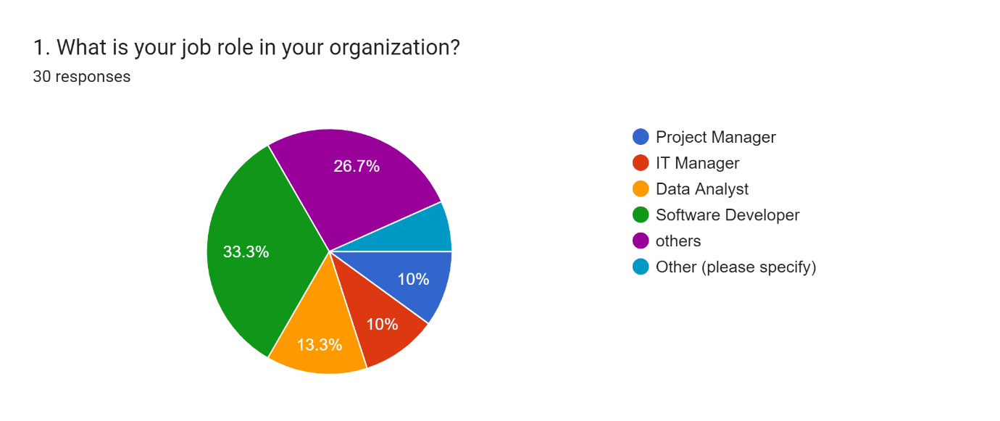

Forms response chart. Question title: 2. How many years of experience do you have in project management?
. Number of responses: 30 responses.

Forms response chart. Question title: 3. How familiar are you with AI technologies in general?
. Number of responses: 30 responses.

Forms response chart. Question title: 4. Is your organization currently using AI tools for project management?
. Number of responses: 30 responses.

Forms response chart. Question title: 5. Which AI tools or applications are being used in your organization for project management? (Select all that apply)
. Number of responses: 30 responses.

Forms response chart. Question title: 6.How frequently do you use AI tools in your daily project management tasks?
. Number of responses: 30 responses.

Forms response chart. Question title: 7. Do you believe that AI has improved project planning and scheduling in your organization?
. Number of responses: 30 responses.

Forms response chart. Question title: 8. Has AI helped in improving risk management in your projects?
. Number of responses: 30 responses.

Forms response chart. Question title: 9. Do you feel that AI has enhanced decision-making processes in project management?
. Number of responses: 30 responses.

Forms response chart. Question title: 10. Has AI contributed to an increase in overall project efficiency?
. Number of responses: 30 responses.

Forms response chart. Question title: 11.How would you rate the impact of AI on improving communication and collaboration within project teams? 
. Number of responses: 30 responses.

Forms response chart. Question title: 12. Do you believe that AI has helped in reducing project costs?
. Number of responses: 30 responses.

Forms response chart. Question title: 13. What are the main challenges faced in integrating AI into project management? (Select all that apply)
. Number of responses: 30 responses.

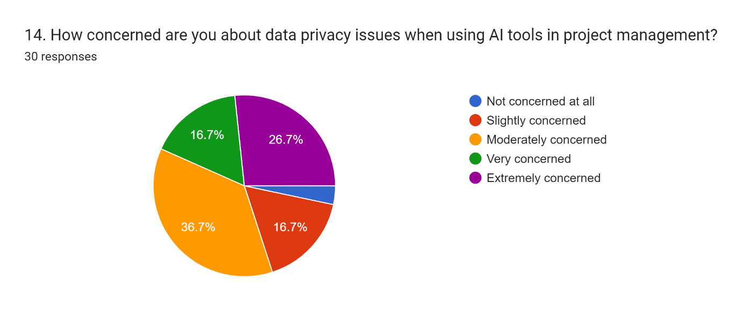

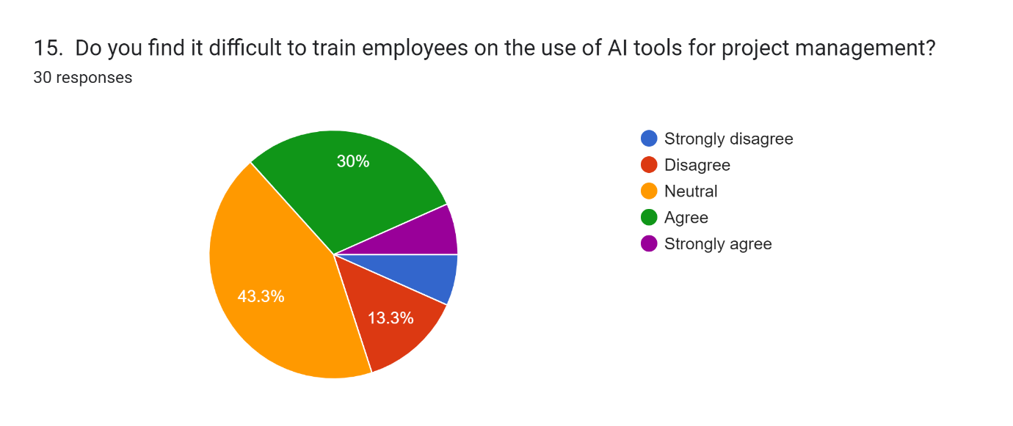

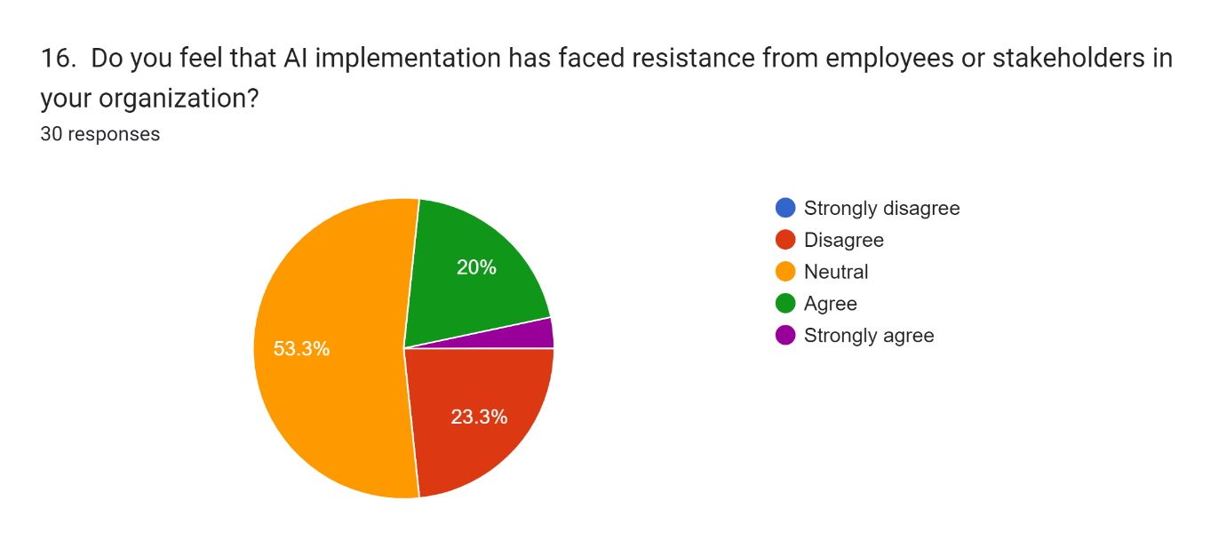

Forms response chart. Question title: 17. How likely is your organization to invest more in AI-based project management tools in the next 12 months?
. Number of responses: 30 responses.

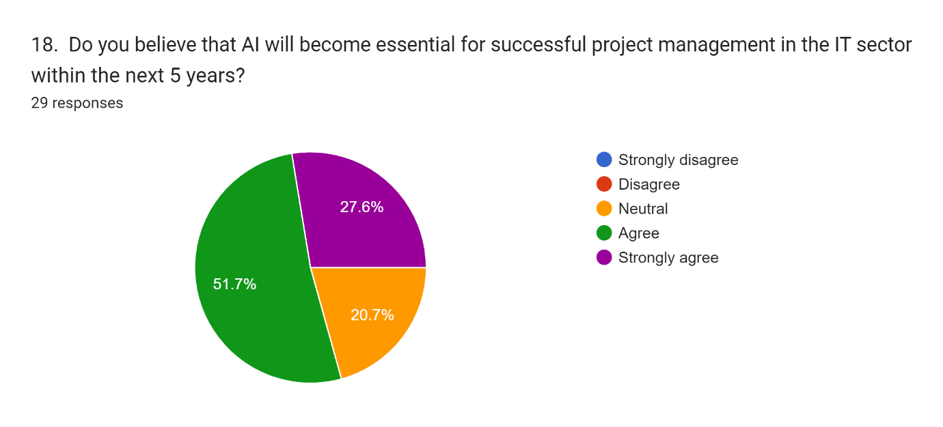

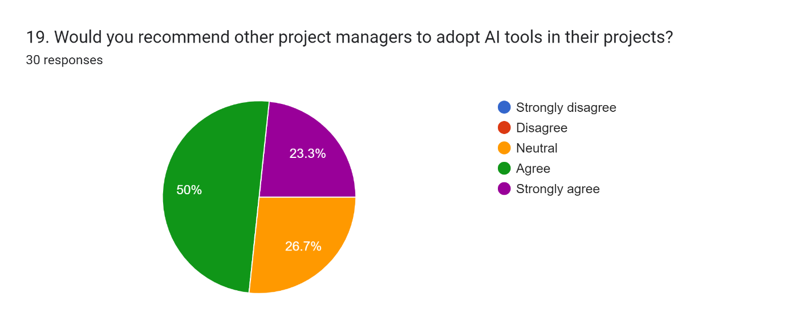

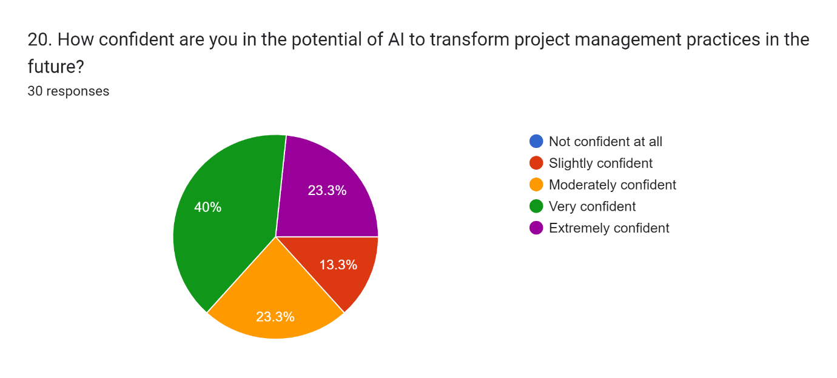

# **Appendix 3: Discussion form**

**Discussion form 1:**



***Leicester Business School***

**Discussion Record Form**

As part of your dissertation process you are required to discuss how your research project should progress with your supervisor. You may therefore keep a record of your discussions and meetings with your supervisor. You can submit as one file a minimum of three signed and dated copies to the Discussion Record Form Turnitin link. These are not marked and are not a requirement.

|  |  |  |  |  |  |
| --- | --- | --- | --- | --- | --- |
| Student | | | | | |
| **Last Name**: | SIVAKUMAR | | | **First Name**: | PRAVEENA |
| DMU **Email** Address: | | P2807605@my365.dmu.ac.uk | | **Student no**. P2807605 | |
| Programme of study: | | **MSc Project Management** | | | |
| **Supervisor** | | | | | |
| **Last Name:** ODUMOSU | | | **First Name:** EMMANUEL | | |
| **Brief Record of Discussion** | | | | | |
| **The first meeting was at campus on 27/06/2024** | | | | | |
| **Actions by the student** | | | | | |
| **Discussed about the topics we had chosen, `and supervisor given the detailed explanation about the dissertation process.** | | | | | |
| **Supervisor comments** | | | | | |
| Student was guided on how to narrow down the research topic and how to carefully select topic, materials that will support the research work. Chapter 1-3 and ethics form was requested to be done before next review. | | | | | |

**Signature of Researcher:** Praveena Sivakumar **Date:** 27/06/2024

**Signature of the Supervisor: ..............** EOdumosu**...................... Date: .....19/09/2024..**

**Discussion form 2:**



***Leicester Business School***

**Discussion Record Form**

As part of your dissertation process you are required to discuss how your research project should progress with your supervisor. You may therefore keep a record of your discussions and meetings with your supervisor. You can submit as one file a minimum of three signed and dated copies to the Discussion Record Form Turnitin link. These are not marked and are not a requirement.

|  |  |  |  |  |  |
| --- | --- | --- | --- | --- | --- |
| Student | | | | | |
| **Last Name**: | SIVAKUMAR | | | **First Name**: | PRAVEENA |
| DMU **Email** Address: | | P2807605@my365.dmu.ac.uk | | **Student no**. P2807605 | |
| Programme of study: | | **MSc Project Management** | | | |
| **Supervisor** | | | | | |
| **Last Name:** ODUMOSU | | | **First Name:** EMMANUEL | | |
| **Brief Record of Discussion** | | | | | |
| **Review for dissertation draft on 15/09/2024 via mail.** | | | | | |
| **Actions by the student** | | | | | |
| **Sent review of my draft and supervisor kept few comments and few things need to be added and change.** | | | | | |
| **Supervisor comments** | | | | | |
| Before analysing the main area of the research put the demography of the work and analyse the outcome before the main section. Use appropriate visual presentation for the work. | | | | | |

**Signature of Researcher:** Praveena Sivakumar **Date:** 15/09/2024

**Signature of the Supervisor: ...............** EOdumosu**......................... Date: ....19/09/2024.**

**Discussion form 3:**



***Leicester Business School***

**Discussion Record Form**

As part of your dissertation process you are required to discuss how your research project should progress with your supervisor. You may therefore keep a record of your discussions and meetings with your supervisor. You can submit as one file a minimum of three signed and dated copies to the Discussion Record Form Turnitin link. These are not marked and are not a requirement.

|  |  |  |  |  |  |
| --- | --- | --- | --- | --- | --- |
| Student | | | | | |
| **Last Name**: | SIVAKUMAR | | | **First Name**: | PRAVEENA |
| DMU **Email** Address: | | P2807605@my365.dmu.ac.uk | | **Student no**. P2807605 | |
| Programme of study: | | **MSc Project Management** | | | |
| **Supervisor** | | | | | |
| **Last Name:** ODUMOSU | | | **First Name:** EMMANUEL | | |
| **Brief Record of Discussion** | | | | | |
| **Communicated via mail on 07/08/2024** | | | | | |
| **Actions by the student** | | | | | |
| **Review for first three chapters and discussed about the ethical form. Supervisor advised me some changes in the ethical form and research questions.** | | | | | |
| **Supervisor comments** | | | | | |
| You have few open-ended questions in the questionnaire . Are you doing a mixed method analysis? If not change them to a close ended so u could all have same likert scale format.  Your work is confusing in terms of which method you are approaching this research. If you are doing qualitative and thematic analysis, your research questions should be strictly open-ended questions only. | | | | | |

**Signature of Researcher:** Praveena Sivakumar **Date:** 07/08/2024

**Signature of the Supervisor: .............** EOdumosu**.................... Date: ....19/09/2024**